MUSIC WEBSITE

Synopsis

Submitted in partial fulfillment of the requirement for the degree of

**BACHELOR OF TECHNOLOGY**

**IN**

**COMPUTER SCIENCE & ENGINEERING**

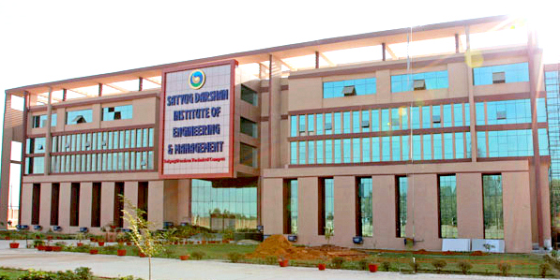

2021 **-** 2022

**Submitted To :** **Submitted By :**

**AAYUSH JOSHI**

**ADITYA SHARMA**

**ANJALI PAL**

**ACKNOWLEDGEMENT**

I would like to take this opportunity to thanks everybody who guided me and extended possible help for the successful completion of the project **“Project title”**. This work would not have been a reality without the permission of **Mr. ________,** Head of Dept. (CSE).

I am indebted to **Mr. ____________,** Project Guide, to whom I owe the success of this project, for his whole hearted corporation and guidance, which helped me in overcoming the teething problems of an industrial environment and carrying on the project work smoothly.

I am thankful to all the members of my team involved in the development of project. I am also indebted to my friends whose moral support always inspired me to come out with the best.

Last but not the least, my project would not have seen the light of the day without the blessings of my parents which was a constant help in the times of need.

**ABSTRACT**

Although a substantial number of research projects have addressed music information retrieval

over the past three decades, the field is still very immature. Few of these projects involve

complex (polyphonic) music; methods for evaluation are at a very primitive stage of

development; none of the projects tackles the problem of realistically large-scale databases.

Many problems to be faced are due to the nature of music itself. Among these are issues in

human perception and cognition of music, especially as they concern the recognizability of a

musical phrase. This paper considers some of the most fundamental problems in music

information retrieval, challenging the common assumption that searching on pitch (or pitch-

contour) alone is likely to be satisfactory for all purposes. This assumption may indeed be true

for most monophonic (single-voice) music, but it is certainly inadequate for polyphonic (multi-

voice) music. Even in the monophonic case it can lead to misleading results. The fact, long

recognized in projects involving monophonic music, that a recognizable passage is usually not

identical with the search pattern means that approximate matching is almost always necessary,

yet this too is severely complicated by the demands of polyphonic music. Almost all text-IR

methods rely on identifying approximate units of meaning, that is, words. A fundamental

problem in music IR is that locating such units is extremely difficult, perhaps impossible.

Keywords: information retrieval, searching, music, audio, MIDI, notation.

**TABLE OF CONTENTS**

**S.No. Particulars**

1. **Introduction of Project**

* Title
* Problem Statement
* Overview
* Scope9

1. **Methodology**

* Using Software Bootstrap ,VScode & Java Scrip
* Using Language [ HTLM , PHP , CSS ]
* Architecture
* Process Flow Diagram/DFD
* Requirement

**3. Technology to be Used**

* Database Details
* Development Tools & Technologies

**4 .Gantt Chart**

**5. References**

**INTRODUCTION OF PROJECT**

**MUSIC WEBSITE**

It's challenging to truly describe music in words. We all know how it makes us feel, and we know what we like when we hear it, but actually communicating this is the hard part. Author Victor Hugo wrote that “Music expresses that which cannot be put into words and that which cannot remain silent." Henry Wadsworth Longfellow described it as "the universal language of mankind."

Music is a form of art that uses sound organised in time. ... Most music includes people singing with their voices or playing musical instruments, such as the piano, guitar, drums or violin. The word music comes from the Greek word (mousike), which means "(art) of the Muses".

"My music is the spiritual expression of what I am - my faith, my knowledge, my being ... When you begin to see the possibilities of music, your desire to do something really good for people, to help humanity free itself from its hangups ... I want to speak to their souls."  

**PROBLEM STATEMENT FOR MUSIC WEBSITE**

**1.Implications and a Catalog of Problems :**

In our discussion of Segmentation and Units of Meaning, we commented that “in music as in

text, there are many ways to ‘say’ the same thing.” The identities of musical entities are

stubbornly resistant to certain types of transformation. Simple examples include mutation

(roughly, changing from minor to major or vice-versa); diatonic “transposition” (really scale-

degree shifts); “tonal answers” to fugue subjects (where repetitions of the subject have pitch

intervals distorted to stay within the scale); and varying the number of repetitions of a note. More

complex examples include a myriad 19 ways of ornamenting melodies. This is analogous to the

problem of conflating various ways of expressing the same concept in text: through variants of

the same words, synonymous words and phrases. These considerations mean that searching for

exact matches is of no more use—and quite possibly less—in music than in text IR. Appendix 2

contains a first attempt at a catalog of the problems.

2.**Preliminary Catalog of Problems** :

The list below is a first attempt at categorizing the problems of music IR. “M” means the

problem applies to monophonic music; “P” means it applies to polyphonic music. (Notice

however that, in view of the music-perception phenomena we discussed earlier, even this

distinction is not clear-cut: a single monophonic line is sometimes heard as polyphonic.)

**OVERVIEW**

Have you been debating whether or not you need a website for your music? With social media freely and easily accessible, you may have a great online presence already. So do you really need a website to stand out as a musician?

Yes! If you were to ask a music fan, or an industry expert how best to access your music and find out more about you as an artist, they would point to a dedicated website.

One of the biggest advantages of running a website is that the artist has full control over it. Social media sites have strict terms of service and monitor the content that is posted on their platforms. Instagram may deem a clip from a music video too sexual and remove it or worse still, shut down the account. With their own websites, musicians can decide themselves what kind of content is appropriate and don’t find themselves at the mercy of big co-operations like Facebook. Additionally, while it is clear that social media is growing, it is hard to predict how it will develop over time, whereas the artist can determine the future of their website themselves.

Overall owning a **website** provides artist with the opportunity to curate their personal brand more carefully than social media and provide their fans with a space dedicated to their favorite artists. It gives artists control of their content, brand and future development of their online space.

**USING SOFTWARE**

**BOOTSTRAP , WAMP SERVER AND VSCODE**

**BOOTSTRAP:**

Bootstrap is a free and open-source CSS framework directed at responsive, mobile-first front-end web development. It contains CSS- and JavaScript-based design templates for typography, forms, buttons, navigation, and other interface components.

Bootstrap, originally named Twitter Blueprint, was developed by Mark Otto and Jacob Thornton at Twitter as a framework to encourage consistency across internal tools. Before Bootstrap, various libraries were used for interface development, which led to inconsistencies and a high maintenance burden. According to Twitter developer Mark Otto:

A super small group of developers and I got together to design and build a new internal tool and saw an opportunity to do something more. Through that process, we saw ourselves build something much more substantial than another internal tool. Months later, we ended up with an early version of Bootstrap as a way to document and share common design patterns and assets within the company.

After a few months of development by a small group, many developers at Twitter began to contribute to the project as a part of Hack Week, a hackathon-style week for the Twitter development team. It was renamed from Twitter Blueprint to Bootstrap, and released as an open source project on August 19, 2011. It has continued to be maintained by Mark Otto, Jacob Thornton, and a small group of core developers, as well as a large community of contributors.

**VSCODE:**

**Visual Studio Code** is a streamlined code editor with support for development operations

like debugging, task running, and version control. It aims to provide just the tools a developer

needs for a quick code-build-debug cycle and leaves more complex workflows to fuller featured

IDEs, such as Visual Studio IDE.

Visual Studio Code is a freeware source-code editor made by Microsoft for Windows, Linux and macOS. Features include support for debugging, syntax highlighting, intelligent code completion, snippets, code refactoring, and embedded Git.

**WAMP SERVER :**

WampServer refers to a solution stack for the Microsoft Windows operating system, created by Romain Bourdon and consisting of the Apache web server, OpenSSL for SSL support, MySQL database and PHP programming language.

WampServer is a Web development platform on Windows that allows you to create dynamic Web applications with Apache2, PHP, MySQL and MariaDB. WampServer automatically installs everything you need to intuitively develope Web applications. You will be able to tune your server without even touching its setting files. Best of all, WampServer is available for free (under GPML license) in both 32 and 64 bit versions. Wampserver is not compatible with Windows XP, SP3, or Windows Server 2003.

**USING LANGUAGE [ HTML , PHP , CSS & JAVASCRIPT]**

**HTML:**

* HTML stands for Hyper Text Markup Language
* HTML is the standard markup language for creating Web pages
* HTML describes the structure of a Web page
* HTML consists of a series of elements
* HTML elements tell the browser how to display the content
* HTML elements label pieces of content such as "this is a heading", "this is a paragraph", "this is a link", etc.

**PHP:**

**PHP is an amazing and popular language.**It is powerful enough to be at the core of the biggest

blogging system on the web (WordPress).It is deep enough to run the largest social network

(Facebook).It is also easy enough to be a beginner's first server side language.

* PHP is an acronym for "PHP: Hypertext Preprocessor".
* PHP is a widely-used, open source scripting language.
* PHP scripts are executed on the server.
* PHP is free to download and use.

**CSS:**

CSS is the language we use to style a **Web page**.

* CSS stands for Cascading Style Sheets.
* CSS describes how HTML elements are to be displayed on screen, paper, or in other media.
* CSS saves a lot of work. It can control the layout of multiple web pages all at once.
* External stylesheets are stored in CSS files.

CSS is used to define styles for your web pages, including the design, layout and variations in display for different devices and screen sizes.

**JAVASCRIPT :**

* JavaScript is the **Programming Language** for the Web.
* JavaScript can update and change both **HTML** and **CSS.**
* JavaScript can **calculate**, **manipulate** and **validate** data.

**ARCHITECTURE**

**1. METADATA**

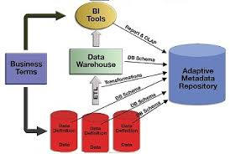

**2.MUSIC ARCHITECTURE**

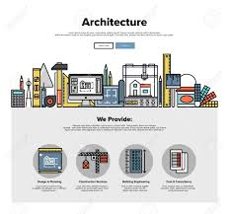

**3.SOFTWARE PATTERN**

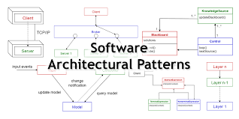

**Process Flow Diagram/DFD**

# [Example of DFD for Online Store (Data Flow Diagram)](https://www.conceptdraw.com/How-To-Guide/online-store-dfd)

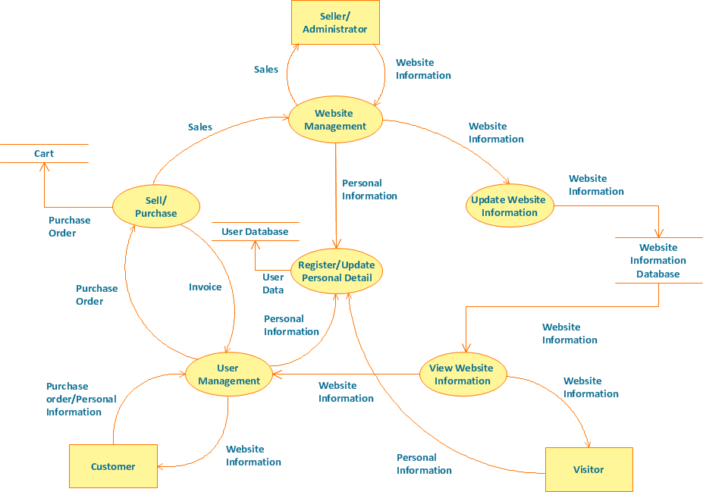

# Technical Flow Chart Example

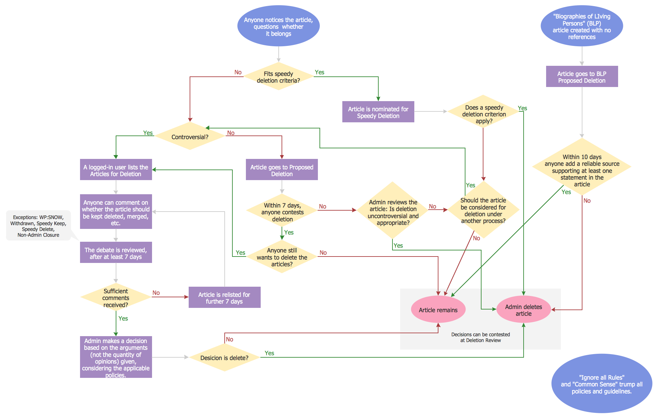

**Requirement**

1. Contact information

This seems obvious, but you want people to be able to reach out to you. Whether they are fans or potential venue owners looking to book your band, you want to be sure they have a valid email address or other form of contact. Be sure to frequently check your inbox and respond to those who are reaching out to you. Digital channels of communication are appreciated because people can reach out instantly, or on their own time.

2. Social media links

You want your website visitors to chose how they want to keep up with your band’s news. Give them the option to find you across the web so they can check up on you whenever and wherever they want.

3. A way to listen…and buy

This will often be one of the main reasons someone visits your site. Whether they’ve heard your stuff before or are just dying to hear their favorite song again, make it easy for them to find your mp3s and purchase links.

4. Gigs

Your fans are super pumped to see you play live. Make it easy for them to find out when you’re playing and how to get there. Provide as much information as you can. Addresses, start times, ticket fees or door charges, and any insight you have about the venue.

5. A well written biography

Spill a little bit about yourself. If a venue is trying to let people know what to expect when you play your show, they’ll often go here and borrow what you’ve written. Go beyond the typical elements of a biography and really share your story. If you’re a band, explain how you all met, what your influences are. Add something personal about each of the members if you can. If you’re a solo artist, share how you got started in the music world.

6. Blog or video blog

Post frequently. Did you have a blast at your last show? Say so! Did one of your bandmates do something hilarious? Write about it. Are you super grateful for every fan you have? Let them know. Have a last minute show pop up? Spread the word.

Your fans want to hear from you and feel connected to you. A blog or video blog is one of the best and easiest ways to keep in touch with them. It also gives people incentive to return to your site frequently.

7. Newsletter sign up

We’ve already covered the reasons for needing a newsletter. Using your website as a collection source is a no-brainer. While social media platforms may come and go, you will always own your email list. Use your list to promote gigs, merchandise, events, and anything else that you want your fans to know about.

8. Photos

High resolution photographs are a great addition to your site. You’ve invested time and resources into making sure your website is polished, make sure your photos are too. While you might not need to hire a pro photographer, make sure your images are high enough resolution to fit their intended space without being stretched.

9. Links to any press or promotions you are included in

Did your local paper write about you? Did a venue or fan post a review of one of your shows? Link to the articles so people can get some outside perspective about your music.

10. A way to track visitors

You can get really complicated with this, but even using just the basic features of Google Analytics or Jetpack for WordPress can give you great deals of insight. Check up on your traffic and analyze it to see how effective your social media promotions, new releases, and blog posts have been. When you see something that is working to drive traffic to your site, you can start to tailor your strategy around what has been most effective.

AudioTheme is designed around making it easy for you to add and maintain great content on your site. See it in action:

**DATABASE DETAILS**

Searching a music database for the missing album information in a music CD disc. Old, as well as many new, music CDs do not contain artist name, album and song titles, but MP3, AAC and other compressed audio formats include fields called "tags" for this data .When a CD is played in the computer or is being ripped to a compressed format, the media player software queries an online database such as CDDB.

**Why Identify the Disc?**

When a song is played, the actual title can be displayed instead of track 01, track 02, etc. If the C

D is being ripped, the titles are automatically entered into the metadata fields of the MP3 or other

 compressed format. Without this service, users have to enter the titles manually for every track

in the album. However, for MP3 collections that were never tagged or improperly tagged when

 the CDs were ripped, there are music databases and tagger programs that add the correct meta-

data (see [**music file identification**](https://encyclopedia2.thefreedictionary.com/music+file+identification)).  
  
**Only Track Number and Time**

When they designed the CD in the early 1980s, they did not set aside a few thousand bytes for de

scriptive data among the 650 million available. An appalling lack of vision in retrospect, meta-

data fields were added many years later .but are not mandatory and not always used.

The only metadata guaranteed to be in a music CD are a table of contents (TOC) with track nu

mbers and lengths, precisely what has been displayed on a consumer CD player since day one. A

lthough not impossible, it is unusual to have two CDs with the same number of tracks and length

s in the same order, and it is this table of contents data that identifies a music CD.

**Development Tools & Technologies**

A **programming tool** or **software development tool** is a **computer** program

that **software** developers use to create, debug, maintain, or otherwise support

other **programs** and applications.

**Web developer tools**

* Firefox – F12 opens the Web Console / Browser Console (since Firefox 4). ...
* Google Chrome – **Chrome Developer Tools** (DevTools)
* Internet Explorer and Microsoft Edge – F12 opens Web Developer Tools (as of version 8)
* Opera – Opera Dragonfly.
* Safari – Safari Web Development Tools (as of version 3)

**There are five main steps on how to develop a music streaming app:**

1. Set the requirements and **create** a list of essential features.
2. Hire a team of experienced developers.
3. **Develop** an MVP version of your **music** streaming service.
4. Get users' feedback and add advanced features.
5. Upgrade the **music** streaming **app** regularly.

**Gantt chart**

### [Bug tracking gantt chart example](https://www.teamgantt.com/software-development-templates/bug-report-tracking-template)

If you use a gantt chart to plan software products, why not use it to track bugs too? This example gives your team an easy place to submit bug reports so developers can get to the bottom of issues quickly.

Task groups are broken down by status (open, in progress, on hold, closed). Simply drag and drop tasks from one status group to the next as it moves through the process. You can also use task colors to indicate priority so everyone knows which bugs to squash first.

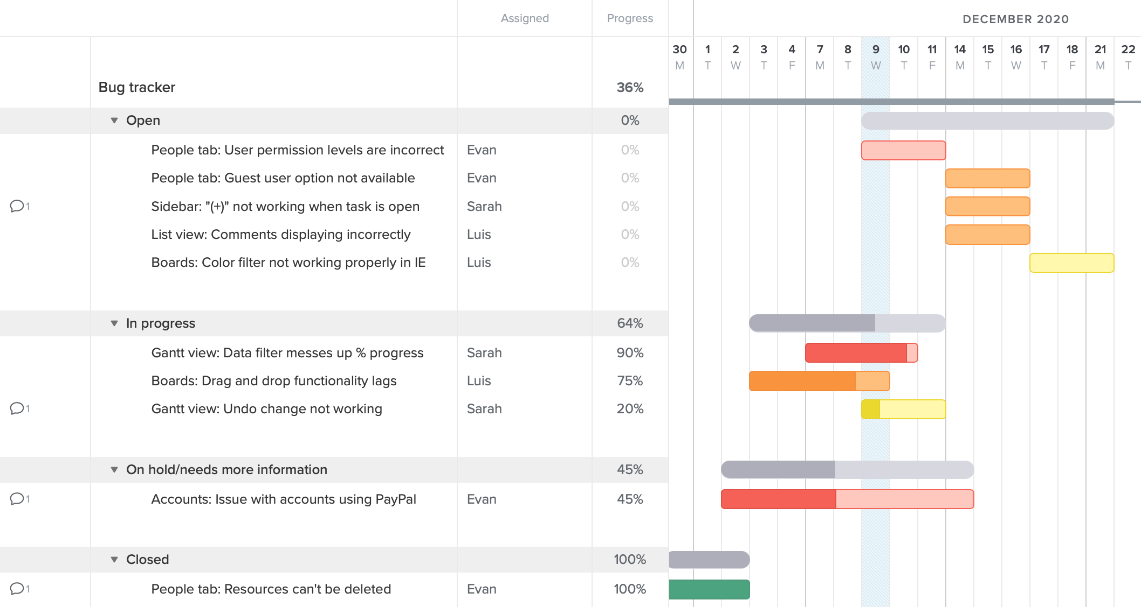

### [Software project plan gantt chart example](https://www.teamgantt.com/software-development-templates/software-development-plan)

Taking a hybrid approach to software development? This example shows you [how to use a gantt chart for an Agile project](https://www.teamgantt.com/blog/how-to-use-gantt-charts-for-your-agile-project). Tasks have been organized into groups based on sprints, with milestones for sprint planning and deployment.

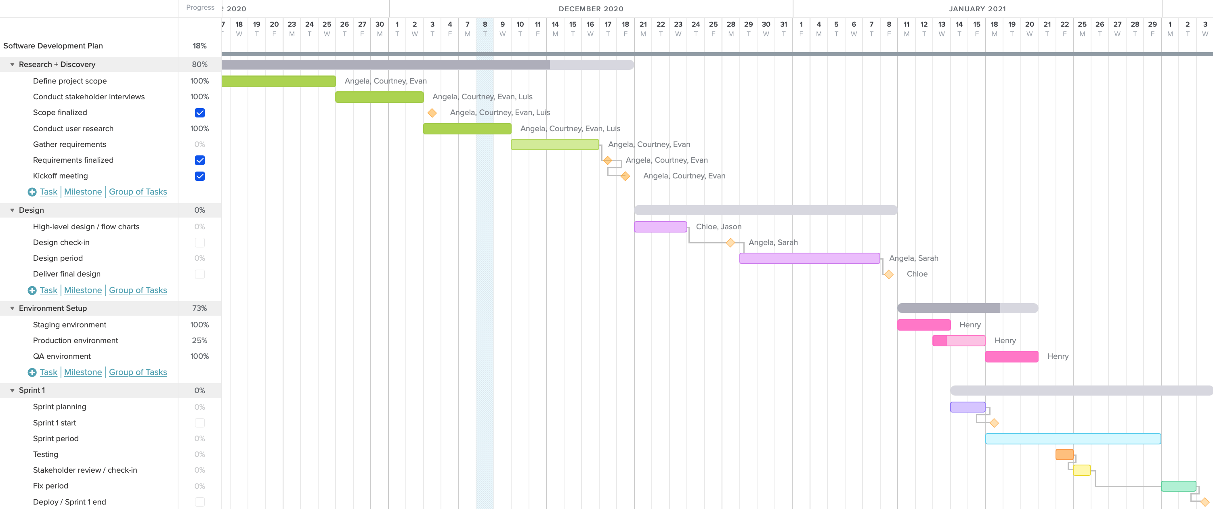

**References**

* **JavaScript** - <https://www.w3schools.com/whatis/whatis_js.asp>
* **BootStrap** - <https://getbootstrap.com/docs/4.0/getting-started/introduction/>
* **HTML -** [**https://www.w3schools.com/html/**](https://www.w3schools.com/html/)
* **CSS** (Cascading Style Sheets) - <https://www.w3schools.com/css/>
* **PHP -** [**https://www.w3schools.com/php/default.asp**](https://www.w3schools.com/php/default.asp)
* **MYSQL -** [**https://www.w3schools.com/php/php_mysql_intro.asp**](https://www.w3schools.com/php/php_mysql_intro.asp)
* **VISUAL CODE STUDIO -** [**https://code.visualstudio.com/download**](https://code.visualstudio.com/download)
* **WAMP SERVER -** [**https://sourceforge.net/projects/wampserver/**](https://sourceforge.net/projects/wampserver/)